6A^{th} Grade: Unit 10, Lesson 10

- Bianca picks blocks out of a bag one at a time. She picks out a block, records the color, and puts the block back in the bag. She cannot see the blocks, but she knows there are 3 blocks in the bag. Of the 10 times she picked a block out of the bag, she picked a blue block 2 times, a red block 5 times, and a yellow block 3 times. What is the ratio for the number of times a blue block was picked?

$\frac{2}{10}$ or $\frac{1}{5}$

- What solution strategy is used when we first find the correct factor, then multiply the numerator and denominator of the sample by that factor?

A scale factor

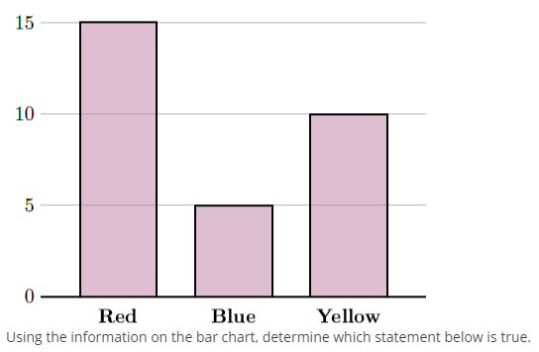
- A group of students were surveyed on which color best represents math. The results are in the bar chart below. How many students say that red best represents math?

15 out of 30 students

